Name : Kanika Yadav

Email ID : [kadik@stevens.edu](mailto:kadik@stevens.edu)

Course number : BIA 650 A

Instructors name : Prof. Edward Stohr

**BIA 650A Optimization and Process Innovation**

**Fall 2022**

**Developing a Decision Support System for a Major Retail Company using Simplex Algorithm**

I pledge on my honor that I have not given or received any unauthorized assistance on this assignment/examination. I further pledge that I have not copied any material from a book, article, the Internet or any other source except where I have expressly cited the source.

Name : Kanika Yadav

Signature : _Kanika Yadav_ Date: _16th November 2022_

======================================================

**Grading Rubric**

Proposal Objectives and Criteria ___/4

Understand the Data ___/4

Model Development ___/4

Partial Excel Solution ___/4

Conclusion and DSS Proposal ___/4

**TOTAL ____/20**

**Proposal Objective and Criteria –**

For the given dataset, we have the initial launch of the product style line and their unit cost with price we could deduce the profit margin for the product line for the Clothing retailer.

Here we are given an objective to do the pricing and cost analysis, to target sale of complete available inventory within 36 weeks from the date of launch of the product line.

If we look at the data set, we have weekly data as well as dataset collected on 03/29/2015, where we can see there was a sale of approximate 500-800 units of each style with profit margin of 55- 75% which varies across the product line.

We need to figure out what would be the best optimal solution to have the best strategy to make the highest or have the optimal solution to attain maximum profit margin for the remaining set of inventory with the company and within 36 week from the date of launch.

Here we need to identify the Revenue generated for each product line that will help in retrieving the optimal profit margin solution.

**Understand the Data –**

Currently the data set is given in three formats –

1. Initial Product style cost and price
2. Sale data for 19.42 weeks - Profit Margin attained by 03/29/2015 since product launch on November 13.
3. A week sale data - Number of items sold in a week from 03/29 to 04/04

Although the given data looks to be perfect in terms of values there is a defect in the inventory items hold within the system. This can be considered as discrepancy no matter how perfect we would like to have the data to be

**Assumption-** Since the number of units are already available we restrict and put a constraint based on 36 Weeks to sell off all the inventory. This will help us to define the target selloff within stipulated time and with maximum Profit Margin.

**Model Development-**

For the current given problem statement, we have following constraint to find an optimal solution –

1. Ending inventory to be zero meaning- Sell all inventory for all the products
2. Complete this in stipulated number of days that is 36 weeks from start of the launch of product.
3. Maximize the profit margin

Based on given dataset values, we are left with 110 days (i.e. 15.72 weeks) of 36 weeks to sell of the Inventory of stock for each product style.

Although by Pareto principle there are 20% factors that affect the 80% of sells of Clothing which is rightly applicable in this case, we try to stick with our strict stringent lines of sales based on our Simplex Liner programming to solve this problem.

Hence, we have 15.72 weeks to sell off all the given product styles at the clothing store,

We could calculate the inventory available on 4/5/2015. Based on the same we could derive the average sell off required per week per item by keeping a check on the number of weeks to target sell off for all the items. For the coming weeks we can keep a target based on calculations of average sell per item based on total number of items available in the inventory

The average sell per item could be derived by dividing the inventory to be sold with number of weeks to achieve target selloff. Hence the average number of items to be sold can be considered as one of the constraints and major factor to consider while solving this problem.

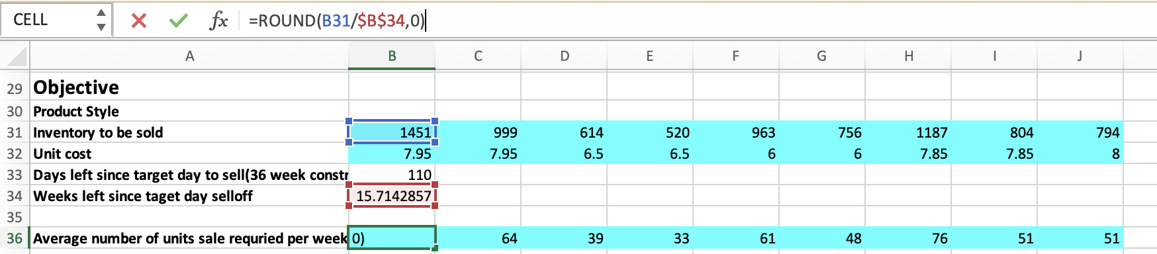

Now that we have number of units to be sold per week, we can keep the price as our Changing variable to reach maximum profit margin.

Now the Cost of production of the inventory units is already given we could calculate multiplying by unit cost per unit. Revenue generation can also be calculated based on number of sold units by selling price at which they are sold which will be a Changing variable in this case.

In the next section we will see how we applied the Simplex Algortihm to solve the problem and how we can apply DSS system for such problems in future.

Sensitivity and Optimality of the solution with Simplex algorithm of Pigskin’s model -

The number of product sold for each product style variant for next 15.72 weeks can be defined using the Pigskin’s model. In reality, however there could be a variance in the number of items sold as it depends on the Demand of the type of cloth and product offered. There could be various factors which needs to be considered to solve this problem but we will restrict to the given parameters at hand.

1. The optimal solution to Pigskin’s model specifies the production level for each of the next six months. In reality, however, the company would probably implement the model’s recommendation only for the first month. Then at the beginning of the second month, it would gather new forecasts for the next six months, months 2 through 7, solve a new six-month model, and again implement the model’s recommendation for the first of these months, month 2. If the company continues in this manner, we say that it is following a six-month rolling planning horizon.
2. The first six rows are for sensitivity to changes in the storage capacity, whereas the last six are for sensitivity to changes in the demand.
3. Based on solver table results, the conclusion is optimal production quantity in month 1 is fairly insensitive to the possibly inaccurate forecasts for months 5 and 6.
4. For Multiperiod production model, the total optimal cost solution is - $15,64,837.50

Your Task

1. The goal is to sell the inventory of all products within 36 weeks (from Week 1) and the objective is to maximize your profit margins.
2. Please write a proposal (length 600 – 700words) in WORD describing the steps and methodology/models you would use if this project was assigned to you.
3. Include the sample spreadsheet calculations for at least one product line.
4. Describe the decision support system (DSS) you propose to develop (See W&A Ch 3, P.18)

**References**